**RFID Based Intelligent Trolley System using Zigbee**

**Aniket Wani, Krutika Thakur, Nikhil Vaze, Meeta Vadhel, Prof. Rupali Advirkar**

**ABSTRACT**: One of the important aspects of modern electronic technology is embedded systems based on micro controllers. The main aim of science has always been to make our lives easier. In this paper, we discuss an innovative concept of Radio Frequency Identification(RFID) which is used to implement an Intelligent Shopping and billing trolley. Some of the issues faced by customers while shopping are:

* Wastage of valuable time while standing in long queues at the billing counter.
* No track of expenditure.

We observed that the main cause for long queues at the billing counter is not the crowd but the time spent in scanning each and every item using the Bar code Technology.

Our project consist of an RFID based trolley that communicates with the billing side using a ZIGBEE(NRF24L01) module. The RFID reader scans all the items as and when they are put in the trolley. The record of the items bought is stored in the micro controller memory along with their individual costs as well as the total expenditure.This information will be displayed on a LCD screen which will also be placed on the trolley for the customer to verify the item bought and to keep a track on the amount spent on each item. At the billing side, the employee can get an itemized bill from each and every trolley just by giving the trolley number as the input to a software which would then print the itemized bill. Data can be erased from the micro controller memory after the bill is printed so as to make that trolley reusable.

KEYWORDS: Radio Frequency Identification (RFID), Wireless ZigBee Module, Infra-Red (IR) transmitter and receiver,RFID tags, Micro controller, Server database.

**I.INTRODUCTION**

1.1 Motivation:-

➢ *Reason Behind Choosing Micro controller Based System:*

In this paper, we have designed system by using micro controller, because micro controller based system are less bulky and also easily transferable. It requires less power. So the system becomes cheap. It requires less space, easy to install, so can fitted easily in the robot.

➢ *Benefits To The Customers*

In this project we have included a LCD screen where the customer can view each and every item being scanned and at the same time the total bill generated will also be viewed on the screen which would help the customer keep track on the expenditure.

**1**.2 Generic Approaches (Present Status):-

Micro controller based design, has acquired the status of most happening field in electronics. This is highly specialized field that has the power of integrating thousands of transistors on single silicon chip. Nowadays, in mall for purchasing variety of items it requires trolley. Every time customer has to keep a track on the cost of each item and match it with his budget in the the pocket. After the tedious procedure of shopping, customer has to wait in queue for billing. So, to avoid headache like - waiting in billing queue, thinking about budget. We are introducing new concept that is

“RFID based Intelligent Trolley using ZIGBEE”

**II.PROPOSED MODEL AND ASSUMPTIONS**

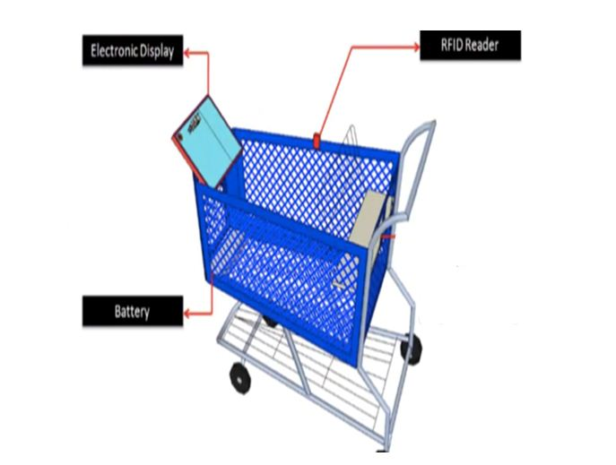

**FIG. A**

**TROLLEY SIDE**

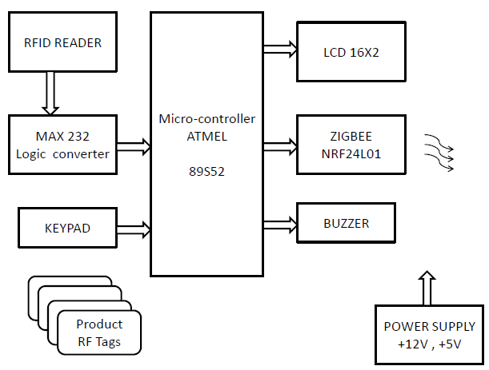

**FIG. B**

**BILLING SIDE**

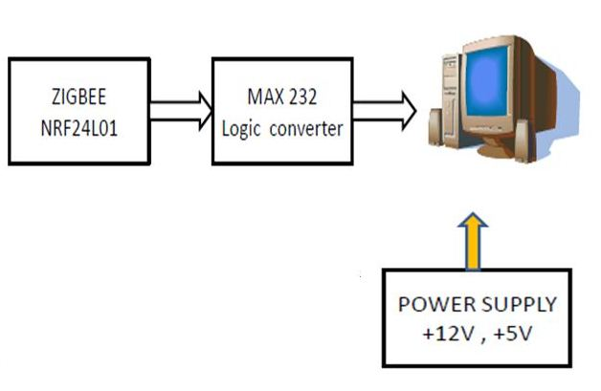

**FIG. C**

**III.SYSTEM DESCRIPTION**

Figure A, B and C depicts a block diagram containing the subsystems of intelligent trolley. Each subsystem is interfaced carefully to form a whole unit. This system consists of a micro controller interfaced with RFID, ZigBee, RFID Tags, LCD 16x2 display, forming the hardware unit and ZigBee interfaced to the server making up the software unit. When any product containing RFID tag is placed in the trolley, it is detected and information is collected. The RFID tags have a unique ID number. RFID tags are used to uniquely identify products. This information is then sent to the main server using the wireless ZigBee unit. The data sent is the unique number. At the server end, the database is queried based on the unique number. All the products and their respective details stored in that particular database are retrieved and sent back to the shopping trolley. The information received from the server is temporarily stored in the shopping trolley memory and then displayed on the display unit affixed on the trolley. The customer can then select the product with the information being shown on the display unit. Every product is uniquely identified using RFID tags. As the products are selected and added into the cart, the RFID reader will identify the product and the price will be added to the temporary bill. If a customer chooses to drop a selected product, it needs to be done by selecting the appropriate button (“Add/Remove”) on the display unit. After completing the shopping, the customer has to select the “Complete” button. This enables the total bill being generated after confirmed purchase of all the selected products in the shopping trolley. This generated bill is sent to billing side computer to get the computerized bill. At the same time, this information is sent to the database server through the wireless ZigBee unit [2]. The integrated system is built around AT89S52 micro controller and 16x2 LCD display unit and miscellaneous circuit including power supply.

**IV.DEVELOPMENT BOARD**

The development board is hand held, battery powered micro controller board ideal for personal, educational and research robotics projects. Based on AT89S52 micro controller, the Development board includes 64K of flash RAM, inputs for variety of sensors like RFID reader,Zigbee Module and a 16x2 alpha numeric LCD screen.

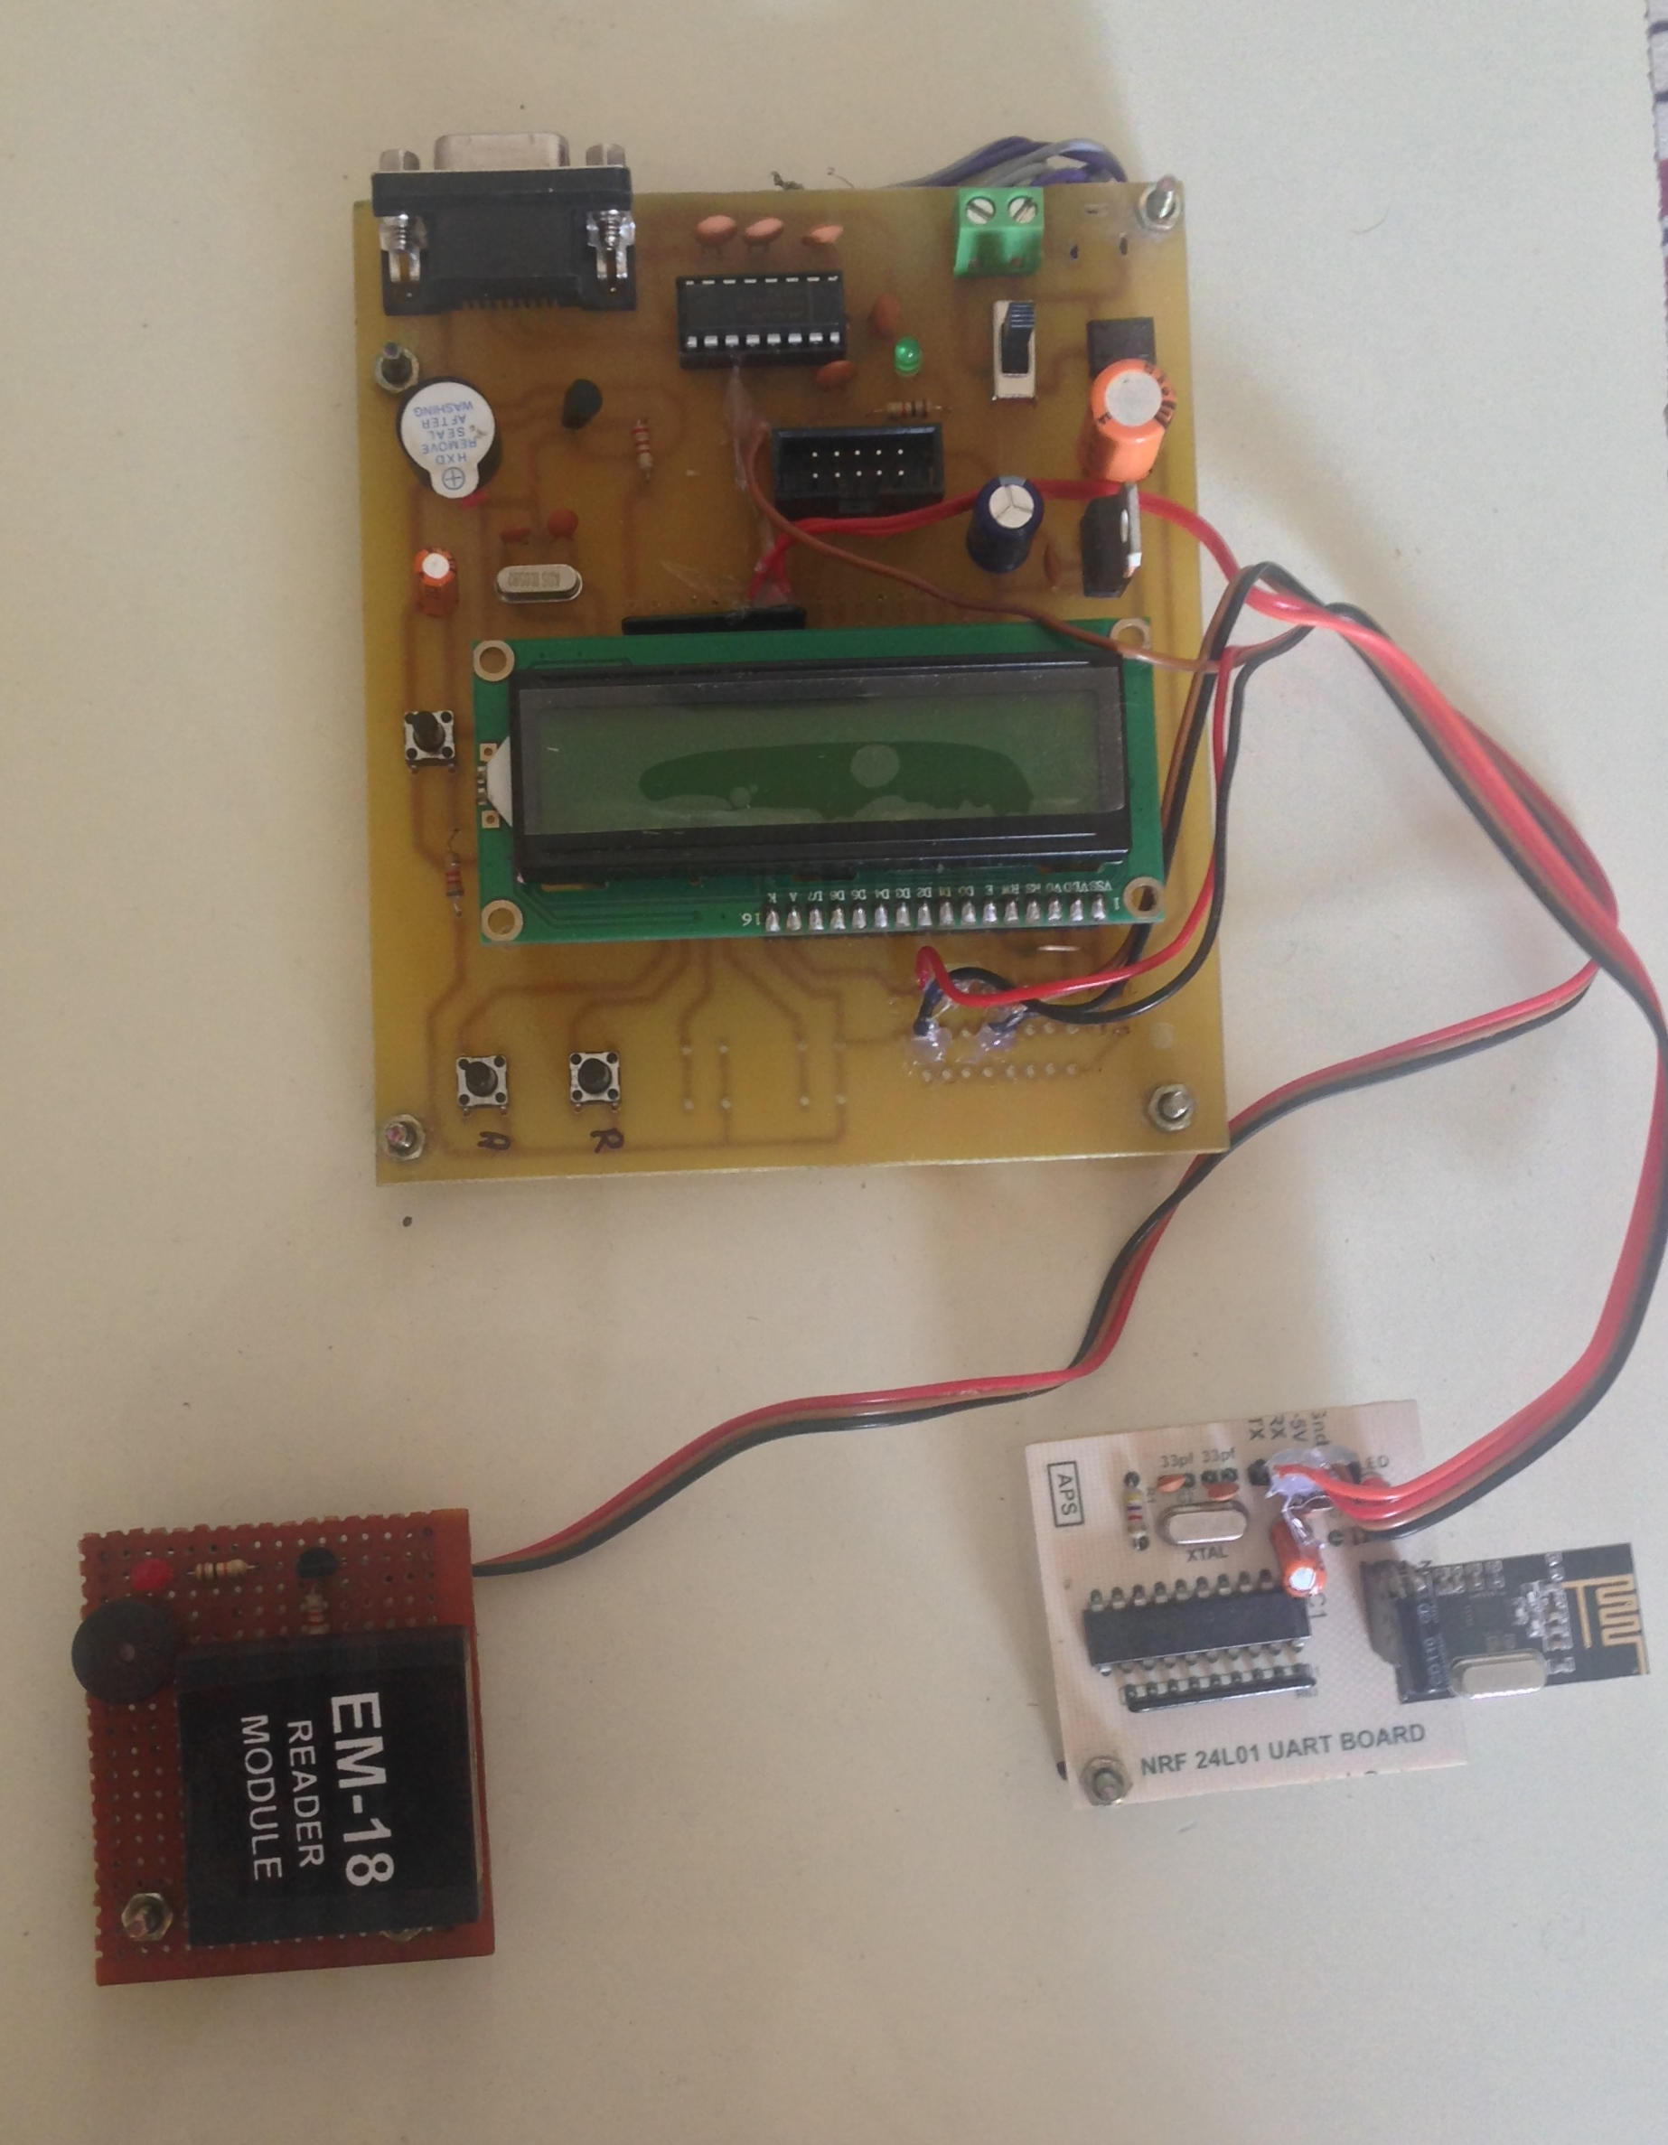

**V. SOFTWARE DESIGN**

Programming involves two steps. First step is to write and compile the code and generate the “*.hex” file. Second step is to load this “*.hex” file on the micro controller using Flash Magic software provided by NXP (formerly Phillips).We are going to use Keil-U-Vision (Version 3) software for writing the code for the Micro controller.

On the billing side we would be making a software for getting the itemized bill, print the bill and empty the trolley. This software will be made using Visual Studio Basic and programming would be done in C-Sharp.

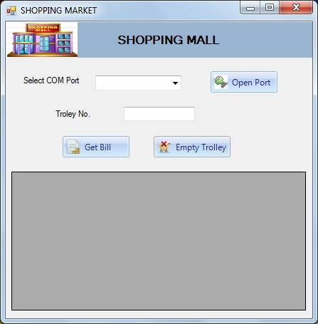

**VI.WORKING**

1) Every product has an RFID tag which contains a Unique ID. These ID’s are fed in the database assigned to the corresponding products.

2) If there needs to be a purchase done, then that product can be dropped in the cart where the RFID reader reads the tag. The information of the product is extracted and displayed on the LCD screen. At the same time billing information is also updated.

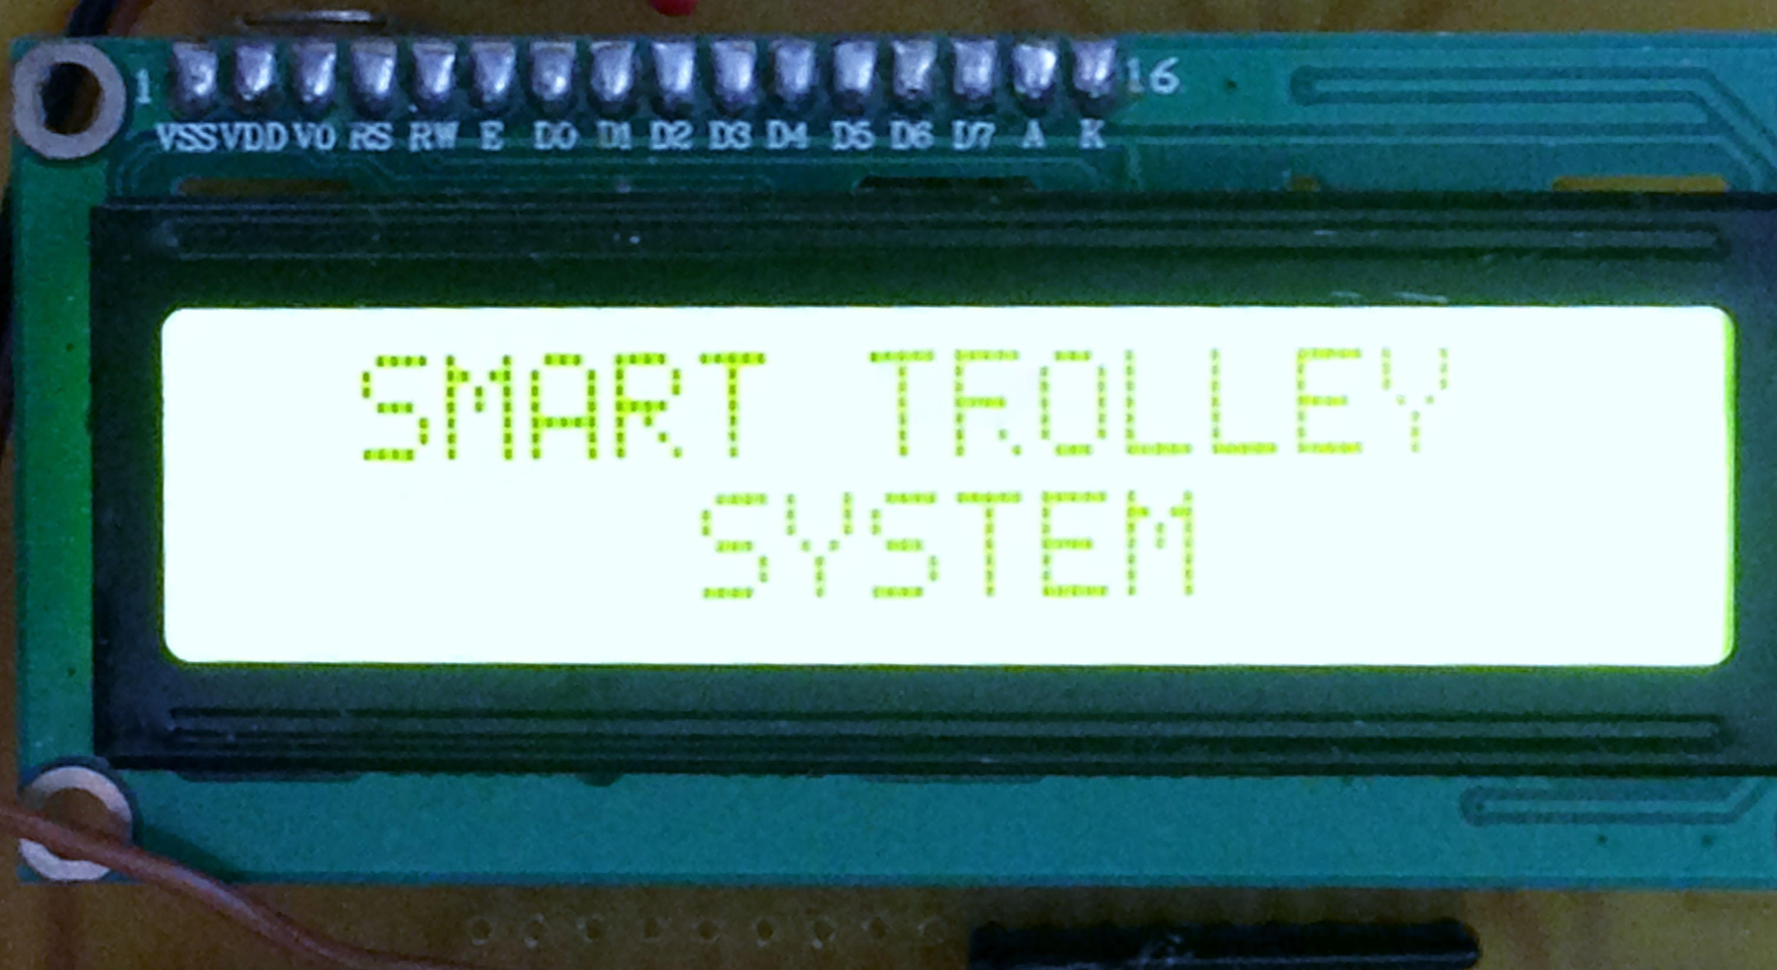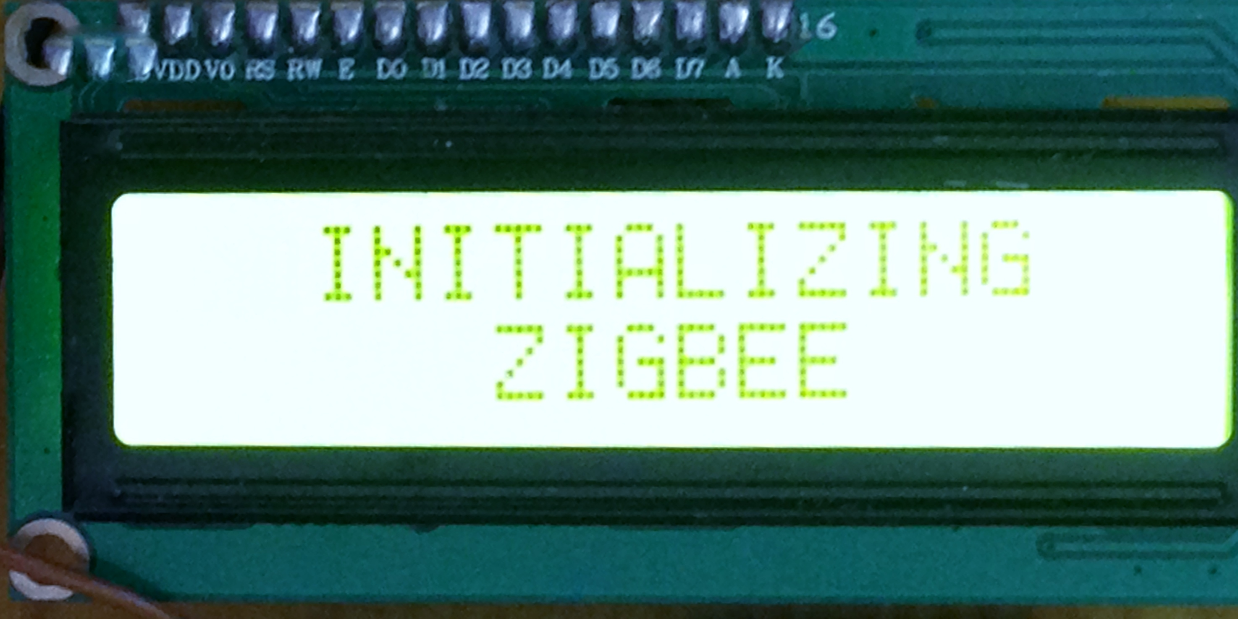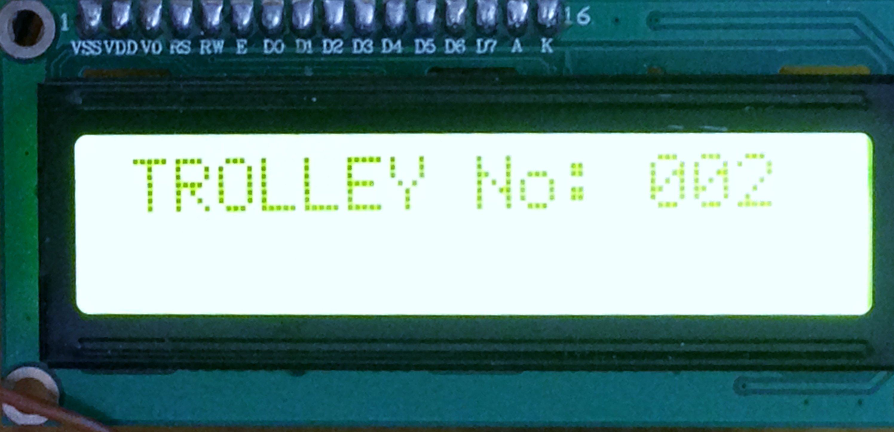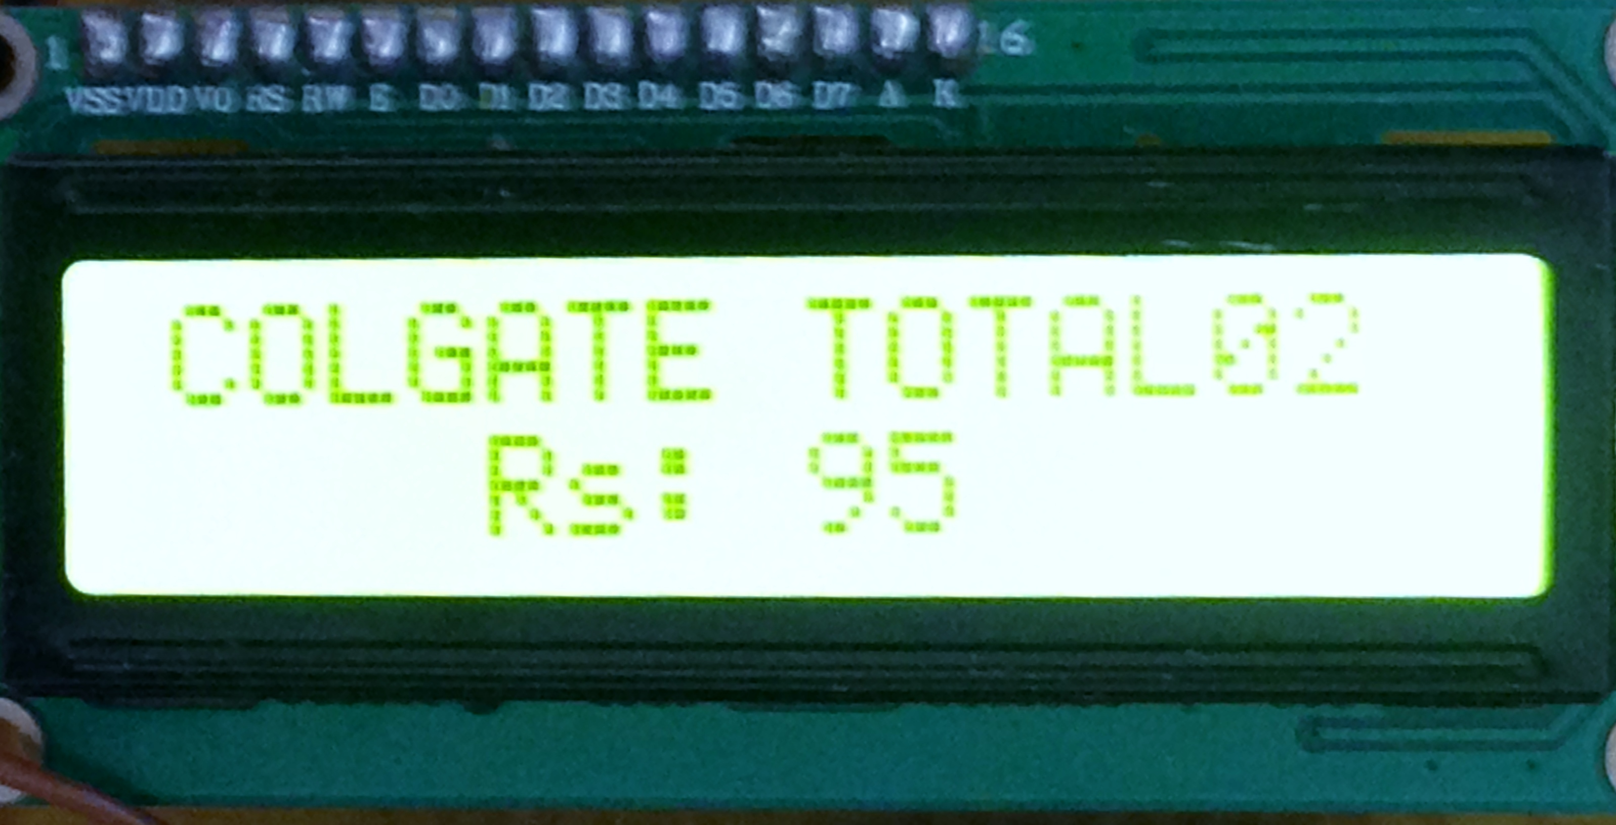

1. When a customer wants to remove any product from the trolley, then that product needs to be scanned again. There will be two options on the LCD screen “ADD” and “REMOVE”. By selecting desired button one can add or remove any product from the cart.

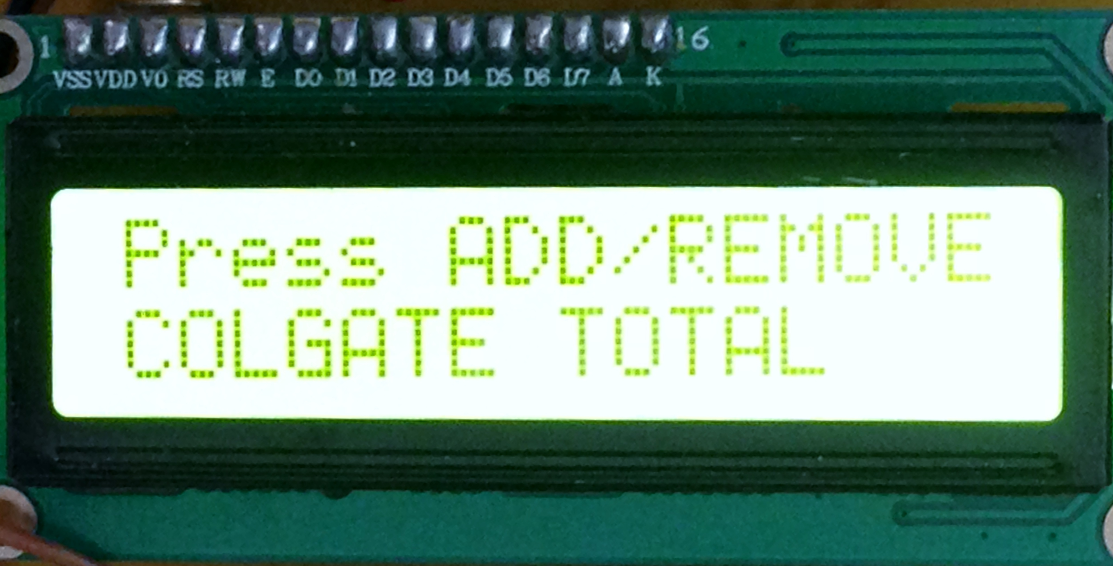

1. At the same time the billing information is updated. The total amount of purchases is also displayed on screen

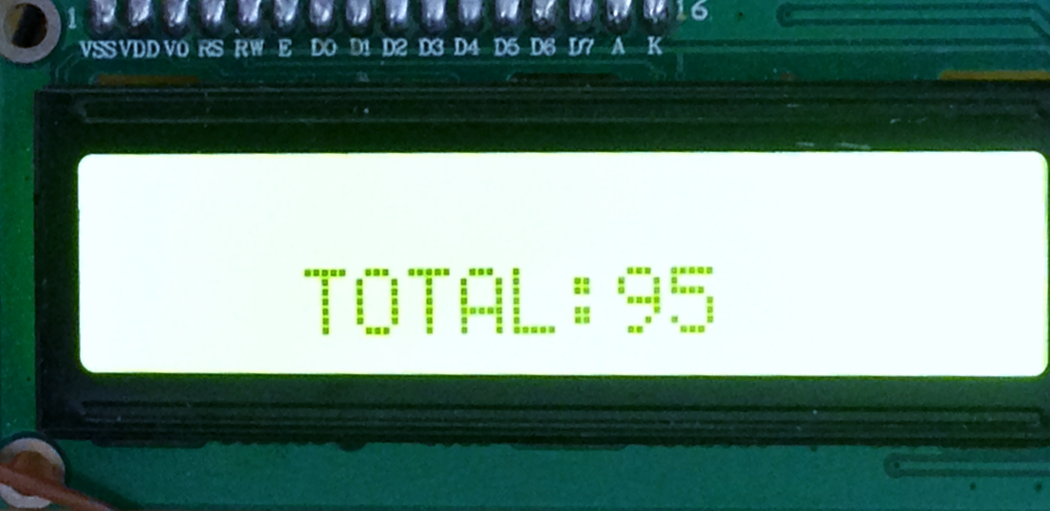

5) These steps are repeated until the end of shopping button or send bill button is pressed. This generated bill is sent to billing side computer to get the computerized bill.

6) At the end of shopping, the customer is asked for the trolley number, to generate computerized bill.

7) The customer can straight away pay the bill and leave.

8) Inventory status of the products is also updated at the end of shopping. Simultaneously the temporary data present in micro controller is reset by pressing “empty trolley”, so that it can be reused.

**VII. CONCLUSION**

Our experience with Smart Shopping has indicated that there are several technical challenges to be met in deploying a pervasive retail system. First, technologies that capture information about interactions between physical objects are not yet mature enough for the consumer market as they are relatively costly. Even when such data becomes available the task of interpreting it is often as challenging as its registration, since no standardized classification scheme or appropriate taxonomy exists. Several efforts to create standards are underway but are still at least years away. A related problem is that new systems must be integrated in existing retail infrastructures, which often operate using legacy and incompatible systems. Moreover, the deployment of retail causes significant growth in electronic transaction loads which current systems are unable to cope with.Although considerable advances have been made in this area, developing and maintaining such applications is still a major challenge.

**References**

[1] Dr.Suryaprasad J, Praveen Kumar B O, Roopa D Arjun A K, A Novel Low-Cost Intelligent Shopping Cart, Proceedings of the 2nd IEEE International Conference on Networked Embedded Systems for Enterprise Applications, NESEA 2011, Perth, Australia, December 8-9, 2011

[2] Swati Zope, Prof. .MarutiLimkar, “RFID based Bill Generation and Payment through Mobile”,

International Journal of Computer Science and Network (IJCSN), Volume 1, Issue 3, June 2012

[3] G. Roussos and B. College, “Enabling RFID in Retail”, Computer, IEEE, vol. 39, no. 3, 2006, pp. 25-30.

[4] Cisco Internet Business Solution Group survey document, My Shopping My Survey Findings, <http://www.cisco.com/web/about/ac79/docs/retail/Mashop-surveymetricsUNITED> STATES.pdf

[5] American Time Use Survey http://www.bls.gov/tus/charts/

[6] http:// www.rfidjournal.com

[7] http://en.wikipedia.org/wiki/zigbee